CA683 Data Analytics

**Human Action Recognition**

**WEIZMANN Dataset**



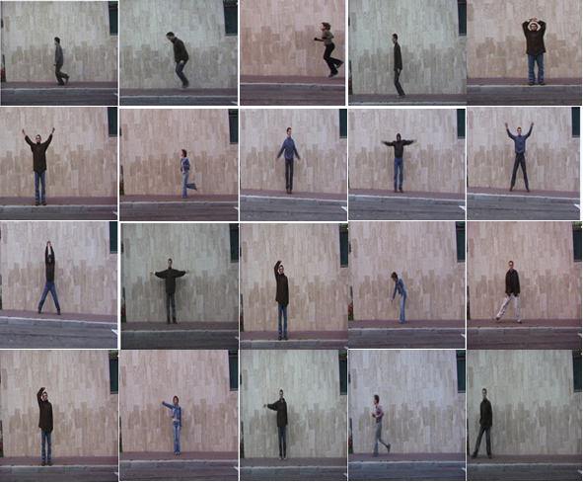

By:  
Ahmad Shaad Safwi (17210439)  
Harshika Dixit (17210042)  
Jyoti Rawat (17210438)  
Srinivas Prashanth Valekar (17210551)

**Introduction:**

WEIZMANN dataset consists of ninety-three videos of people performing ten (classes) actions; Bend, Walk, Run, Skip, Jack, One-hand wave, Two-hand wave, Gallop sideways, Jump, Jump in Place. Our goal is to classify the human actions and compare the different classifier for the same date on the basis of their accuracy involving different image filtering techniques.

**Problem Question:**

The goal is to classify human actions. The complication of this data is in the variety of actions and the similarity in the frames of different actions.

**Process Flowchart:**

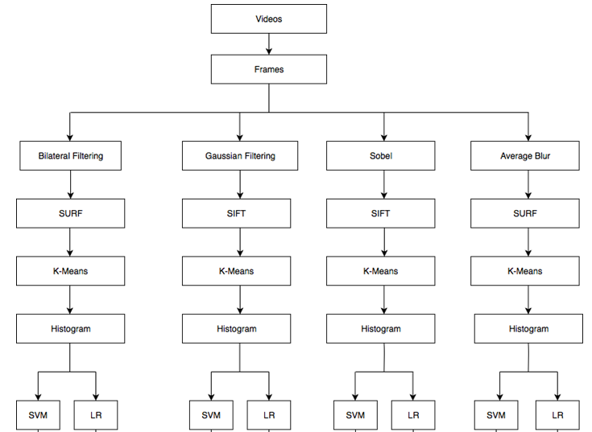

**Video Data Collection:**

We collected our dataset from the WEIZMANN classification dataset which has ZIP file containing uncompressed AVI videos of one of the actions performed by the subjects. Total size of the database is ~340MB. This is the link for it: <http://www.wisdom.weizmann.ac.il/~vision/SpaceTimeActions.html>Following are the classes of actions in the video dataset:

* [Walk](http://www.wisdom.weizmann.ac.il/~vision/VideoAnalysis/Demos/SpaceTimeActions/DB/walk.zip)
* [Run](http://www.wisdom.weizmann.ac.il/~vision/VideoAnalysis/Demos/SpaceTimeActions/DB/run.zip)
* [Jump](http://www.wisdom.weizmann.ac.il/~vision/VideoAnalysis/Demos/SpaceTimeActions/DB/jump.zip)
* [Gallop sideways](http://www.wisdom.weizmann.ac.il/~vision/VideoAnalysis/Demos/SpaceTimeActions/DB/side.zip)
* [Bend](http://www.wisdom.weizmann.ac.il/~vision/VideoAnalysis/Demos/SpaceTimeActions/DB/bend.zip)
* [One-hand wave](http://www.wisdom.weizmann.ac.il/~vision/VideoAnalysis/Demos/SpaceTimeActions/DB/wave1.zip)
* [Two-hands wave](http://www.wisdom.weizmann.ac.il/~vision/VideoAnalysis/Demos/SpaceTimeActions/DB/wave2.zip)
* [Jump in place](http://www.wisdom.weizmann.ac.il/~vision/VideoAnalysis/Demos/SpaceTimeActions/DB/pjump.zip)
* [Jumping Jack](http://www.wisdom.weizmann.ac.il/~vision/VideoAnalysis/Demos/SpaceTimeActions/DB/jack.zip)
* [Skip](http://www.wisdom.weizmann.ac.il/~vision/VideoAnalysis/Demos/SpaceTimeActions/DB/skip.zip)

**Extracting Frames:**

We used OpenCv to extract the frames from the videos.

[Extracting Frames Source Code](https://github.com/harshika-dixit/HumanActivityRecognition/blob/master/Code/frames_extract_code.ipynb)

|  |  |  |  |
| --- | --- | --- | --- |
| **Actions** | **Number of Videos** | **Duration(Sec)** | **Number of Frames** |
| Walk | 10 | 23 | 716 |
| Run | 10 | 11 | 411 |
| Jump | 9 | 12 | 479 |
| Gallop Sideways | 9 | 13 | 381 |
| Bend | 9 | 21 | 596 |
| One-hand wave | 9 | 24 | 653 |
| Two-Hands wave | 9 | 22 | 625 |
| Jump in place | 9 | 17 | 600 |
| Jumping jack | 9 | 26 | 730 |
| Skip | 10 | 15 | 490 |
| Total | 93 | 184 | 5681 |

Following dashboard summarises the video count, duration and frame count with respect to each class. This will provide us data understanding.

**Storing frames as per the action class:**

Then the extracted frames were stored in the folders which were named as per action class. So for each action, we have a folder and respective frames are in it.

**Loading data:**

After storing it, data was loaded using python libraries.

**Changing the format to make processing accessible:**

Files are in “jpeg” format thus took the action class from the folder and assigning it to the “y” value.  
“x” value is array obtained from the image. Our final prepared data is the list of list.

**Splitting data into Train and Test:**

Dataset has been distributed into test and train by taking 70% as training and 30% as testing data.

**Image filtering techniques:**

All the team-members explored different methods of image-filtering (Gray, Bilateral Filtering, Sobel, Gaussian Blur, Average Blur, Median Blur).

We finalised to go forward with following image-filtering and feature-extraction techniques:

**Sobel**

***What is it:*** Sobel calculates not only the magnitude of the edges, but also their direction. The resulting image uses Pythagoras to generate the magnitude of the edges and inverse tan to get the direction of the edges.

***Why used it:*** Approach was to get more defined filtering output so that feature extraction can also be more focused.

**Gaussian Blur**  
  
***What is it:*** A Gaussian filter is a linear filter. It's usually used to blur the image or to reduce noise/contrast.

***Why used it:*** It's faster than other blur techniques because multiplying and adding is probably faster than sorting and then performing mathematical operations.

**Bilateral Filtering**  
***What is it:*** This filtering technique smoothes the color and prevents the averaging of the edges. It is non-linear.

***Why used it:*** Bilateral filters are non-iterative and non-linear, so we will have good spectrum of filtering techniques applied.

**Average Blur**

***What is it:*** It is a non-linear filter. Unlike linear filters, average blur replaces the pixel values with the average value available in the local neighbourhood.

***Why used it:*** Gaussian blur will be very basic and linear filtering so approach was to analyse the results came out of averaging.

**Feature Extraction:**

**SIFT  
  
*What is it:*** Scale Invariant Feature Transform (SIFT) is a feature based object recognition algorithm. It is much advanced than simple corner detectors.  
  
***Why used it:*** Feature extracted are more accurate (recall rates) than other techniques, it is scale invariant. Although our dataset is not rotated or illuminated but for complex data, this feature extraction is even more useful.

**SURF  
  
*What is it:*** Speed-Up Robust Features is used for extracting features from images. This algorithm is similar to SIFT. It firsts find key points of same objects in different images, then it searches for the right orientation of the points and then computes the descriptor, which provides the data of how the neighbourhood of the features points looks like.  
  
***Why used it:*** SURF provides similar performance as SIFT but it runs faster.

**Project Plan:**

1. Each member will perform a filtering technique and a feature extraction method
2. Through extracted feature, we will obtain K-Means and then we will get histogram
3. Modelling (SVM and Logistic)
4. Accuracies will be obtained from both models
5. ROC will be analysed for each model
6. Consolidate and compare the results
7. Conclude which model and which technique is best for WEIZMANN dataset

**Methods with screenshots and source code links:**

**SOBEL+SIFT+K-means🡪 SVM & LR: Evaluated by ROC (**[**Source code**](https://github.com/harshika-dixit/HumanActivityRecognition/blob/master/Code/Sobel_And%20_SIFT.ipynb)**)  
  
 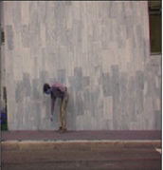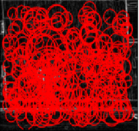**

|  |  |  |
| --- | --- | --- |
| **#Clusters** | **SVM** | **Logistic** |
| 50 | 10.635 | **15.626** |
| 250 | 11.674 | 11.467 |
| 500 | 14.141 | 13.368 |
| 750 | 9.922 | 14.616 |
| 1000 | **15.448** | 14.438 |
| 1250 | 12.061 | 12.477 |
| 1500 | 11.229 | 12.774 |
| 2000 | 13.844 | 10.219 |

***Accuracy vs. Number of Clusters (SVM and Logistic)*  
 SVM Logistic** **ROC  
 SVM Logistic**



**Bilateral Filtering +SURF+K-means🡪SVM & LR:Evaluated by ROC(**[**Source code**](https://github.com/harshika-dixit/HumanActivityRecognition/blob/master/Code/Bilateral_Filtering_and_SURF.ipynb)**)**

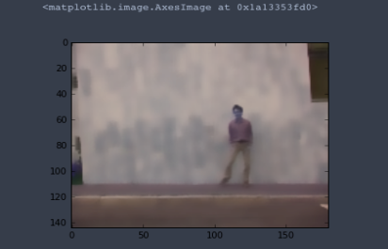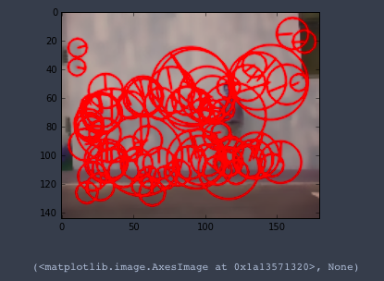

|  |  |  |
| --- | --- | --- |
| **#Clusters** | **SVM** | **Logistic** |
| 50 | 22.52 | 16.21 |
| 250 | 30.51 | 26.14 |
| 500 | 38.91 | 31.62 |
| 750 | 47.55 | 38.80 |
| 1000 | 42.47 | 51.00 |
| 1250 | 52.45 | 42.65 |
| 1500 | 56.65 | **62.66** |
| 2000 | **70.12** | 46.97 |

***Accuracy vs. Number of Clusters (SVM and Logistic)***

**SVM Logistic**

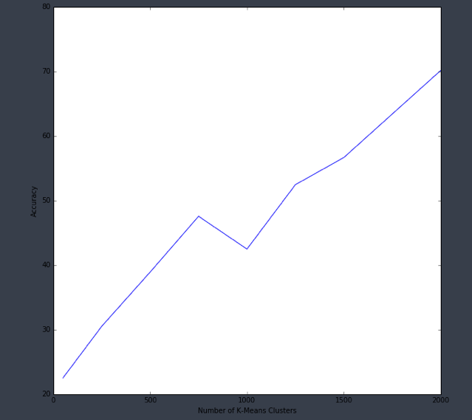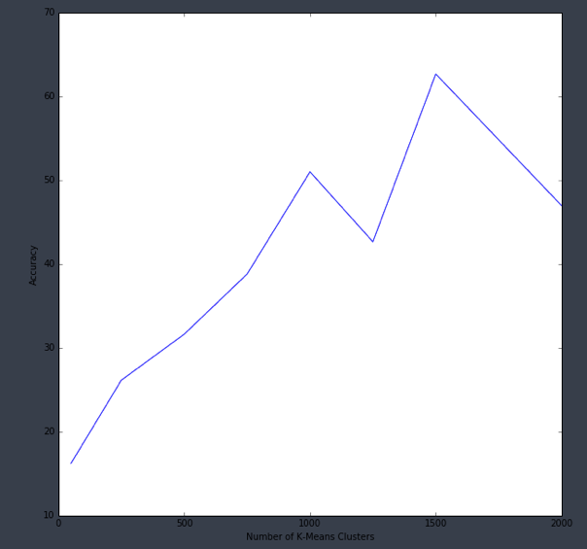

**ROC**

**SVM Logistic**

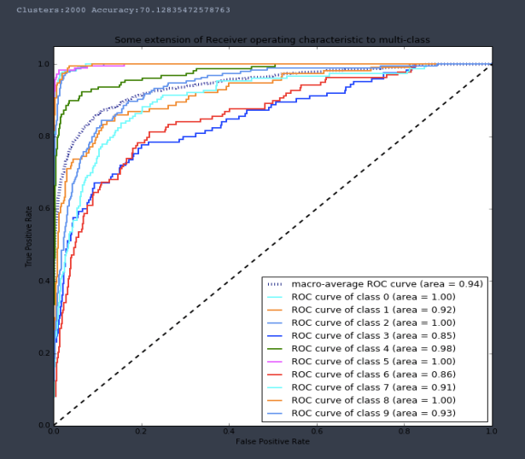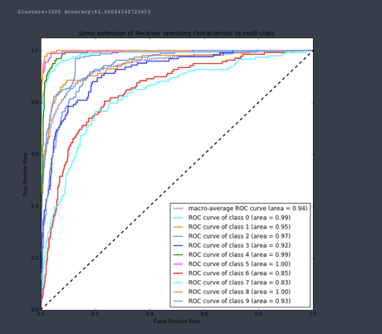

**Average Blur +SURF +K-means🡪 SVM & LR: Evaluated by ROC (**[**Source code**](https://github.com/harshika-dixit/HumanActivityRecognition/blob/master/Code/AvgBlur_and_Surf.ipynb)**)**

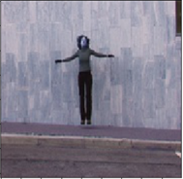 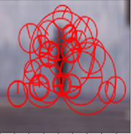

|  |  |  |
| --- | --- | --- |
| **#Clusters** | **SVM** | **Logistic** |
| 50 | 11.876 | 13.598 |
| 250 | 14.845 | 10.273 |
| 500 | 10.867 | **27.613** |
| 750 | 16.924 | 19.121 |
| 1000 | 16.508 | 24.822 |
| 1250 | 19.239 | 26.009 |
| 1500 | 16.686 | 26.247 |
| 2000 | **23.397** | 21.318 |

***Accuracy vs. Number of Clusters (SVM and Logistic)***

**SVM Logistic**

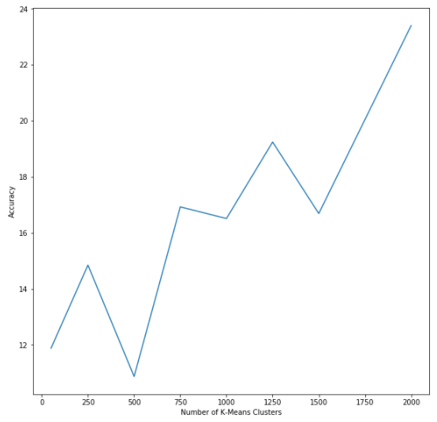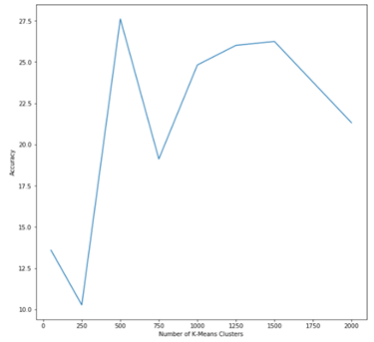

**ROC**

**SVM Logistic**

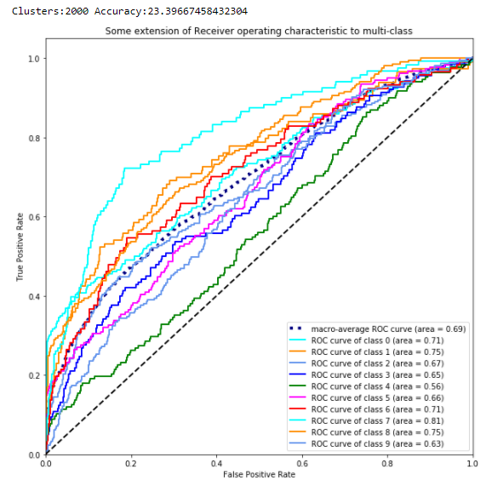 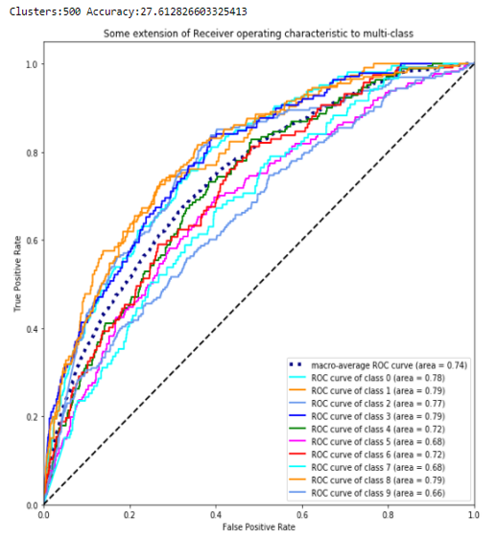

**Gaussian Blur + SIFT + K-means🡪 SVM & LR: Evaluated by ROC (**[**Source code**](https://github.com/harshika-dixit/HumanActivityRecognition/blob/master/Code/GaussianBlur_and_SIFT.ipynb)**)  
  
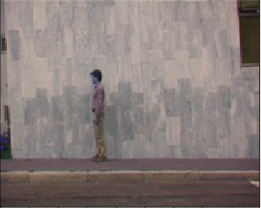 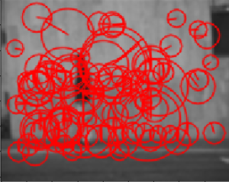**

|  |  |  |
| --- | --- | --- |
| **#Clusters** | **SVM** | **Logistic** |
| 50 | 21.049 | 24.723 |
| 250 | 36.735 | 34.694 |
| 500 | 37.143 | 40.816 |
| 750 | 54.694 | 40.117 |
| 1000 | 58.309 | 55.977 |
| 1250 | 57.143 | 55.743 |
| 1500 | 69.038 | 63.382 |
| 2000 | **78.542** | **66.822** |

***Accuracy vs. Number of Clusters (SVM and Logistic)*  
 SVM Logistic**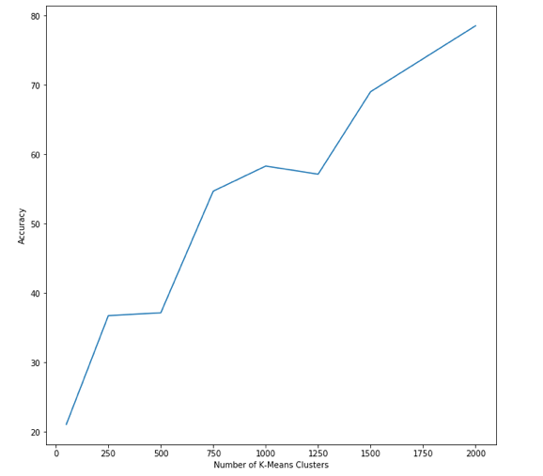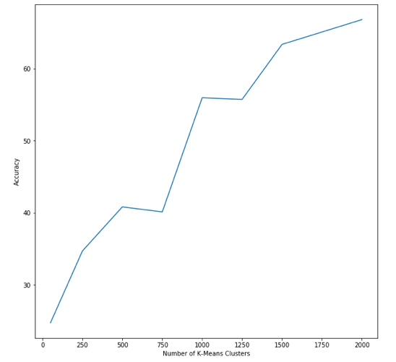

**ROC**

**SVM Logistic**

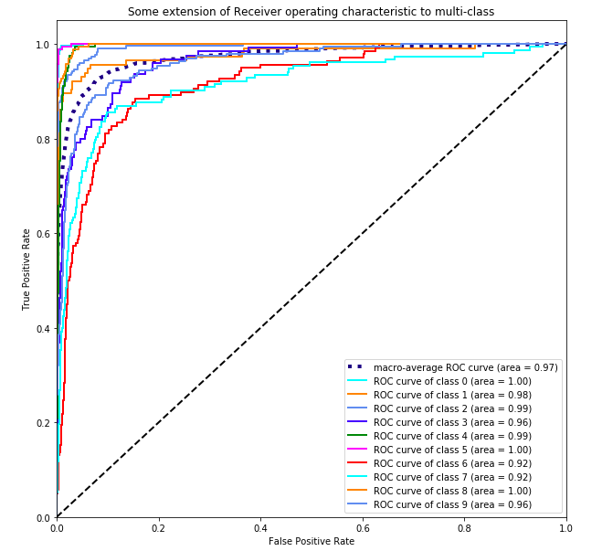 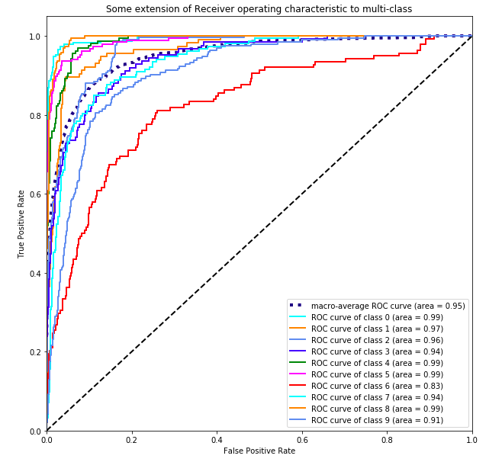

**CONCLUSION:**

|  |  |  |
| --- | --- | --- |
| **Method** | **Accuracy** | |
| **SVM** | **Logistic** |
| Gaussian Blur and SIFT | 78.54 | 66.82 |
| Average Blur and SURF | 23.39 | 27.61 |
| Bilateral Filtering and SURF | 70.12 | 62.66 |
| SOBEL and SIFT | 15.45 | 15.63 |

**Pre-processing Method:**For WEIZMANN dataset, the best method is *Gaussian Blur* for filtering and *SIFT* for feature extraction.  
***Expectation***: Filtering techniques like Sobel and Bilateral will produce more accuracy.  
***Lesson Learnt***: Simple methods can provide better results.

**Model:**SVM provided better results than logistic which is as per expectation.  
***Observation***: SVM ran faster than Logistic for all the methods.

**References:**

[1] Marszałek , Schmid, Marcin , Cordelia, 2006. Spatial Weighting for Bag-of-Features. Spatial Weighting for Bag-of-Features, [Online]. 1, 8. Available at: <https://lear.inrialpes.fr/pubs/2006/MS06/MarszalekSchmid-CVPR06-SpatialWeighting.pdf> [Accessed 3 April 2018].

[2] Yang , Yu , Gong , Huang, Jianchao , Kai , Yihong , Thomas, 2009. Linear Spatial Pyramid Matching Using Sparse Coding for Image Classification. Linear Spatial Pyramid Matching Using Sparse Coding for Image Classification, [Online]. 1, 8. Available at: <http://www.ifp.illinois.edu/~jyang29/papers/CVPR09-ScSPM.pdf> [Accessed 3 April 2018].

[3] Dr. Mubarak Shah. (2018). Lecture 17: Bag-of-Features (Bag-of-Words). [Online Video]. 26 November 2012. Available from: <https://www.youtube.com/watch?v=iGZpJZhqEME>. [Accessed: 1 April 2018].

[4] Azhar , Tuwohingide , Kamudi , Suciati, Ryfial , Desmin ,Dasrit ,Sarimuddin ,Nanik, 2018. Procedia Computer Science. Batik Image Classification Using SIFT Feature Extraction, Bag of Features and Support Vector Machine, [Online]. 72, 7. Available at: <https://www.sciencedirect.com/science/article/pii/S1877050915035620> [Accessed 6 April 2018].

[5] O’HARA AND DRAPER, STEPHEN AND BRUCE A., 2011. INTRODUCTION TO THE BAG OF FEATURES PARADIGM FOR IMAGE CLASSIFICATION AND RETRIEVALe. INTRODUCTION TO THE BAG OF FEATURES PARADIGM FOR IMAGE CLASSIFICATION AND RETRIEVAL, [Online]. 1, 25. Available at: <https://arxiv.org/pdf/1101.3354.pdf> [Accessed 6 April 2018].